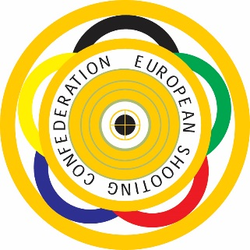

ESC Member Federations
Dear Colleagues, it is my pleasure to inform You about new days of 25m Lapua European Cup competitions at year 2022.
This change has made because of new day for ECH 2022 Wroclaw.
If there will be cancellations of qualification competitions, ESC pistol committee will pick athletes to Final from waiting list.

Sincerely

Marko Leppä
Member of the ESC Technical Committee (pistol)
Leväpolku 1
49400 Hamina

Finland
+358 40 510 5323
marko.leppa@ampumaurheiluliitto.fi

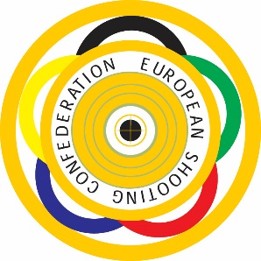
Information of the LAPUA EUROPEAN CUP 25m 2022
REVISED

Center Fire Pistol - and Standard Pistol
The European Cup 25m is a tournament in non Olympic events. ESC also wants to offer for Center Fire Pistol and Standard Pistol shooters a possibility to participate at additional events. Four qualification competitions and the final will be arranged as follow:

1. The first qualification round

will be organized by the German Shooting Sport Federation - Deutscher Schützenbund e.V. in Suhl (GER) 20. – 22.05.2022
www.schuetzenbund.de, brokamp@dsb.de

- The second qualification round

will be organized by the Danish Shooting Union in – Dansk Skytte Union
in Aarhus (DEN) 10. – 12.06.2022
www.skytteunion.dk , info@skytteunion.dk

- The third qualification round

will be organized by the Estonian Shooting Federation – Eesti Laskurliit
in Tallinn (EST) 8. – 10.07.2022

www.laskurliit.ee, info@laskurliit.ee

- The fourth qualification round

will be organized by the Shooting Union of Slovenia – Strelska Zveza Slovenije in Rečica Pri Laškem (SLO) 26. – 28. 08.2022
info@strelska-zveza.si www.strelska-zveza.si

The Final 2022

will be organized by the Portuguese Shooting Federation – Federacao Portuguesa de Tiro in Lisboa (POR) 23. – 25.9.2022
www.fptiro.pt, fptiro@fptiro.net

